Smart Product Labeling and Traceability System for Quality
Control Automation

INTRODUCTION
The Smart Product Labeling and Traceability System for Quality Control Automation is an innovative solution that leverages advanced technologies such as barcode scanning, RFID, and data analytics to track products throughout the supply chain, providing real-time monitoring and improving product safety. This system is designed to enhance quality control automation in manufacturing processes, reducing errors and improving efficiency. By utilizing unique identifiers and real-time data analytics, the system enables manufacturers to quickly identify and recall products in case of quality issues, ultimately improving customer satisfaction and driving business growth. The system is particularly relevant in industries where product safety and quality are paramount, such as food and beverage, pharmaceuticals, and manufacturing.
The implementation of such a system can have a significant impact on various industries, including food and beverage, pharmaceuticals, and manufacturing, where product safety and quality are critical. By providing a transparent and accountable supply chain, the Smart Product Labeling and Traceability System can help manufacturers comply with regulatory requirements, reduce waste, and improve overall product quality, leading to increased customer trust and loyalty.

OBJECTIVES
1. Improve Product Safety: Ensure quick identification and recall of products in case of quality issues, reducing the risk of harm to consumers.
2. Enhance Quality Control: Automate quality control processes, reducing errors and improving efficiency.
3. Increase Transparency: Provide real-time tracking and monitoring of products throughout the supply chain.
4. Ensure Regulatory Compliance: Meet regulatory requirements for product labeling and traceability.
5. Improve Customer Satisfaction: Enhance customer trust and satisfaction by providing accurate and timely information about products.
6. Optimize Supply Chain Management: Improve supply chain visibility, enabling better decision-making and more efficient operations.

PROBLEM STATEMENTS
1. Inefficient Tracking and Monitoring: Manual tracking and monitoring of products throughout the supply chain can lead to errors, delays, and loss of product visibility.
2. Quality Control Issues: Inadequate quality control processes can result in defective products reaching the market, compromising consumer safety and damaging brand reputation.
3. Lack of Transparency: Insufficient transparency in the supply chain can make it difficult to identify the origin, movement, and ownership of products, hindering recall efforts and regulatory compliance.
4. Regulatory Non-Compliance: Failure to meet regulatory requirements for product labeling and traceability can result in fines, penalties, and reputational damage.
5. High Costs Associated with Recalls: Inefficient recall processes can lead to significant costs, waste, and loss of customer trust.
6. Counterfeiting and Tampering: Inadequate product labeling and traceability can enable counterfeiting and tampering, compromising product safety and authenticity.
7. Supply Chain Inefficiencies: Inefficient supply chain management can lead to delays, increased costs, and reduced customer satisfaction.

FLOW DIAGRAM

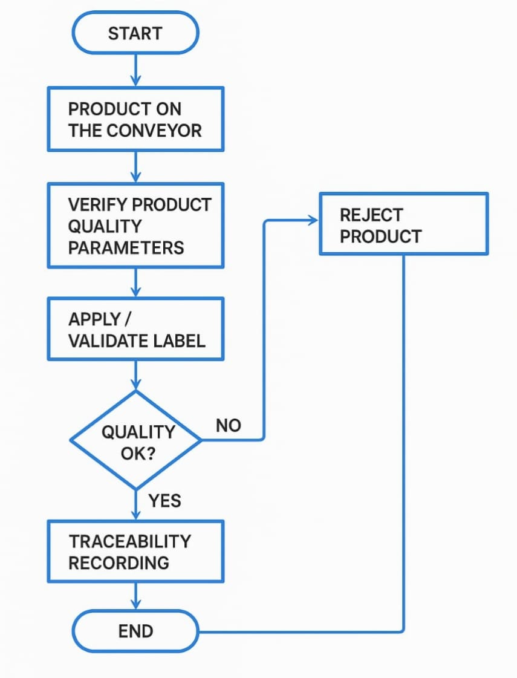

1.START: The automated process begins.
2. Product on the Conveyor: The product is placed or moves onto the conveyor belt system, ready for inspection and labeling.
3. Verify Product Quality Parameters: Sensors, cameras, or automated systems check the product against predefined quality parameters (e.g., size, weight, color, defects).
4. Apply / Validate Label: If the product passes initial checks, a label (like a barcode or QR code) is applied or validated to ensure it is correct and readable.
5. Quality OK?: A decision point where the system evaluates if the product meets quality standards:
YES → Proceed to traceability recording.
NO → Product is rejected and diverted from the main line.
6. Reject Product
The product that fails quality checks is rejected and not allowed to proceed further.
7. Traceability Recording
For products that pass, their details (like batch number, production time, inspection result) are logged into a database/system to enable traceability throughout the supply chain.
8. END
The process ends for this product cycle.

CODE

#main.py
from database_manager import setup_database, get_all_products, get_product_by_id
from product_processor import process_product_pipeline
import json
import os
import qrcode # <--- ADD THIS IMPORT
from PIL import Image # <--- ADD THIS IMPORT
import io # <--- ADD THIS IMPORT
# --- NEW: Simulate QR Code Scanning ---
def simulate_qr_scan():
"""
Simulates scanning a QR code and extracts its content.
For this simulation, you'll manually provide the product_id.
In a real system, you'd use a camera and a QR code reading library.
"""
print("\n--- Simulate QR Code Scan ---")
# Prompt the user for the Product ID that *would be* scanned
scanned_product_id = input("Enter the Product ID from a QR code (e.g., first 8 chars or full ID): ").strip()
if not scanned_product_id:
print("No product ID entered for scan.")
return
# In a real system, the QR code library would extract this.
# For now, we'll assume the input is the exact product_id or a prefix.
# Try to find the exact product ID first
product_record = get_product_by_id(scanned_product_id)
if not product_record:
# If not found exactly, try partial match (like in option 3)
all_prods = get_all_products()
found_matches = [p for p in all_prods if p[1].startswith(scanned_product_id)]
if found_matches:
# If multiple matches, assume the first for simplicity or ask user to clarify
product_record = found_matches[0]
print(f"Found a partial match for '{scanned_product_id}': {product_record[1][:8]}...")
else:
print(f"Product with ID '{scanned_product_id}' not found in traceability system.")
return
display_product_details(product_record)
def display_product_details(product_record):
"""Helper function to display product details from a database record."""
if not product_record:
print("Product not found.")
return
# Extracting data by index as returned by sqlite3 fetchone/fetchall
# Ensure this matches the order in database_manager.py's CREATE TABLE
(id, product_id, batch_id, device_id, manufacturing_date, rohs_compliance,
serial_number, weight_actual, dimensions_actual, visual_quality_ok,
quality_status, label_content_json, label_applied_ok, label_validated_ok,
process_timestamp, rejection_reason) = product_record
print("\n--- Product Details ---")
print(f"Product ID: {product_id}")
print(f"Batch ID: {batch_id}")
print(f"Device ID: {device_id}")
print(f"Manufacturing Date: {manufacturing_date}")
print(f"RoHS Compliant: {'Yes' if rohs_compliance == 1 else 'No'}")
print(f"Serial Number: {serial_number}") # This is the internal serial number, not the QR content necessarily
print(f"Actual Weight: {weight_actual}g")
print(f"Actual Dimensions: {dimensions_actual}")
print(f"Visual Quality OK: {'Yes' if visual_quality_ok == 1 else 'No'}")
print(f"Overall Quality Status: {quality_status}")
if label_content_json:
try:
label_data = json.loads(label_content_json)
print(f"Label Content (Human-readable): {json.dumps(label_data, indent=2)}")
except json.JSONDecodeError:
print(f"Label Content: Invalid JSON - {label_content_json}")
else:
print("Label Content: N/A")
print(f"Label Applied OK: {'Yes' if label_applied_ok == 1 else 'No'}")
print(f"Label Validated OK: {'Yes' if label_validated_ok == 1 else 'No'}")
print(f"Process Timestamp: {process_timestamp}")
print(f"Rejection Reason: {rejection_reason}")
# <--- NEW: Display path to generated QR code if available ---
# Note: QR code path is not stored in DB, but generated in product_processor.
# To retrieve it here from DB, you'd need to add qr_code_path to DB schema.
# For now, we'll just show the path if you processed and remember it.
# Or, a more advanced solution would be to list generated QR files for user to "scan".
# For now, the user types the product ID directly.
print("-----------------------\n")
def main_menu():
"""Presents the main menu for the system simulation."""
setup_database()
while True:
print("\n--- Smart Labeling & Traceability System (Simulated) ---")
print("1. Process New Product")
print("2. View All Products")
print("3. Search Product by ID (Partial)")
print("4. Simulate QR Code Scan") # <--- NEW OPTION
print("5. Exit") # <--- UPDATED OPTION NUMBER
choice = input("Enter your choice: ").strip()
if choice == '1':
batch_id = input("Enter Batch ID for new product: ").strip()
if not batch_id:
print("Batch ID cannot be empty.")
continue
sim_input_choice = input("Provide custom simulated product input? (yes/no): ").lower().strip()
simulated_input = None
if sim_input_choice == 'yes':
print("Enter simulated parameters (leave blank for random):")
device_id = input(" Device ID (e.g., DEV-1234): ").strip() or None
mfg_date = input(" Manufacturing Date (YYYY-MM-DD): ").strip() or None
rohs = input(" RoHS Compliant (1 for Yes, 0 for No): ").strip()
weight = input(" Actual Weight (e.g., 10.1): ").strip()
dimensions = input(" Actual Dimensions (e.g., 10.1x5.0x3.0): ").strip()
visual_ok = input(" Visual Quality OK (1 for Yes, 0 for No): ").strip()
simulated_input = {}
if device_id: simulated_input['device_id'] = device_id
if mfg_date: simulated_input['manufacturing_date'] = mfg_date
if rohs: simulated_input['rohs_compliance'] = int(rohs) if rohs.isdigit() else None
if weight: simulated_input['weight_actual'] = float(weight) if weight.replace('.', '',
1).isdigit() else None
if dimensions: simulated_input['dimensions_actual'] = dimensions
if visual_ok: simulated_input['visual_quality_ok'] = int(visual_ok) if visual_ok.isdigit() else None
simulated_input = {k: v for k, v in simulated_input.items() if v is not None}
process_product_pipeline(batch_id, simulated_input)
elif choice == '2':
products = get_all_products()
if products:
print("\n--- All Processed Products Summary ---")
for p in products:
print(f"ID: {p[1][:8]}..., Batch: {p[2]}, Status: {p[8]}, Rejection: {p[14]}")
print("--------------------------------------")
else:
print("No products processed yet.")
elif choice == '3':
prod_id_input = input("Enter full or start of Product ID to search: ").strip()
if not prod_id_input:
print("Product ID cannot be empty.")
continue
found_records = []
all_prods = get_all_products()
for p_record in all_prods:
if p_record[1].startswith(prod_id_input):
found_records.append(p_record)
if found_records:
if len(found_records) == 1:
display_product_details(found_records[0])
else:
print(f"Found {len(found_records)} products matching '{prod_id_input}'. Displaying first match:")
display_product_details(found_records[0])
else:
print("Product not found.")
elif choice == '4': # <--- NEW OPTION HANDLER
simulate_qr_scan()
elif choice == '5': # <--- UPDATED EXIT OPTION
print("Exiting Smart Labeling & Traceability System. Goodbye!")
break
else:
print("Invalid choice. Please try again.")
if __name__ == "__main__":
main_menu()

ADVANTAGES
1. Improved Quality Assurance: The system ensures that each product is automatically checked against set quality standards. This minimizes the chances of defective products reaching customers and enhances overall product quality.
2. Real-time Traceability: It provides real-time tracking of every product, including origin, production data, and inspection results. This helps in quickly identifying and isolating defective batches if needed.
3. Reduction in Human Error: Automation reduces manual intervention in labeling and data recording, significantly lowering the chances of errors due to human oversight.
4. Faster Inspection and Processing: The use of automated sensors and AI enables high-speed inspection and labeling, ensuring smooth and efficient production line operations.
5. Cost Efficiency: By minimizing product recalls, rework, and labor costs, the system improves overall cost-effectiveness in the production process.

APPLICATION

1. Food and Beverage Industry: Tracking and tracing food products to ensure safety and quality, and to comply with regulations.
2. Pharmaceutical Industry: Ensuring the authenticity and safety of pharmaceutical products, and tracking their movement throughout the supply chain.
3. Manufacturing: Tracking and tracing products and components to improve quality control, reduce waste, and optimize supply chain management.
4. Retail and Logistics: Improving inventory management, reducing counterfeiting, and enhancing customer satisfaction through accurate product labeling and tracking.
5.Healthcare: Ensuring patient safety by tracking medical devices, implants, and pharmaceuticals.
6. Automotive: Tracking and tracing automotive parts and components to improve quality control, reduce waste, and optimize supply chain management.
7. Aerospace: Ensuring the safety and quality of aerospace components and products.

CONCLUSION
The Smart Product Labeling and Traceability System is a vital component of modern quality control automation. By integrating automated inspection, labeling, and real-time tracking, it significantly enhances product quality, operational efficiency, and supply chain transparency. It minimizes human errors, ensures compliance with industry standards, and builds consumer trust through verifiable data. As industries advance towards digital transformation and Industry 4.0, such systems are not only beneficial but essential for maintaining competitiveness, accountability, and long-term success.

